: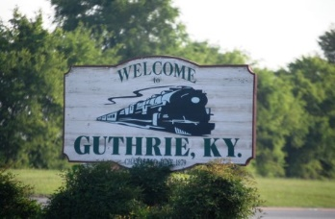

**CITY OF GUTHRIE 2022 EVENTS**

**Sponsorship Form**

Name: ______________________________________________________________________________________

Business Name: _______________________________________________________________________________

Mailing Address: ______________________________________________________________________________

City: _________________________________________ State: ______________ Zip: ______________________

Home Phone: _______________________ Cell Phone: _______________________

Email: ______________________________________________________________________________________

Please Check One:

_____I would like to ___ Sponsor ___ Co-Sponsor the following event *(please reference enclosed flyer for options):*

____________________________________________. ***Someone will contact you to confirm availability of this event.***

_____ Please use my sponsorship dollars wherever needed.

Select Sponsorship Level:

______ $50 ______$100 _____$250 ____$500

_____$1000 ______$2500 OTHER $______________

Please return this form, with check made payable to City of Guthrie (memo City of Guthrie Events 2022), to Alison Blumel, City Clerk, PO Box 125 Guthrie, KY 42234. Or you can use the self-addressed envelope to mail in your sponsorship.

Please remit your Sponsorship and Payment to Guthrie City Hall by June 15, 2022, to assist us in making final plans for the events for 2022

***Thank you*** for your continued support to help make these events possible for

the City of Guthrie, we hope you have a blessed day!